Cyber Justitia: GUI Report

Introduction

Cyber Justitia’s user interface was designed to be accessible, simple, and modular, to maximise accessibility and minimise code to match deadlines. Thus, we created a design that embraces the soft flat design style found in much of software design today, but with a minimal, yet colourful approach. The layout was designed with Bootstrap, which has robust CSS layout features, perfect for responsive and multi-platform design; in addition to custom front-end functionality written in JavaScript and jQuery. We adopted a violet/brown colour scheme, with muted pastel colours included to make the UI look friendlier and more approachable, with smooth, rounded edges on many of the elements within it. The layouts and colour schemes have all been designed in accordance with the Web Content Accessibility Guidelines (WCAG) 2.1.

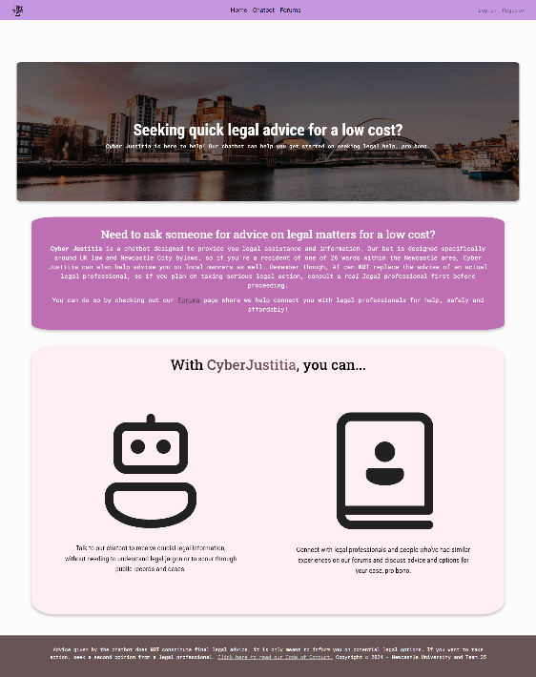Home, General Design & Code of Conduct

Covering the overall layout, the two main elements consistent throughout the pages are: the navigation bar, allowing users to easily navigate throughout different pages of the application, as well as manage their user experience or visit their own profile, and the footer, giving another legal warning, as well as linking to the code of conduct and copyright information. They are both violet and brown respectively to reinforce the colour palette theme.

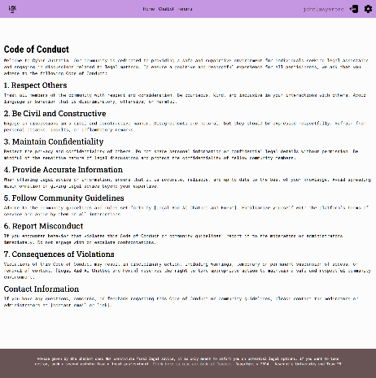When loading the web application, the user will be met with the home landing page, with bold text at the very top describing what Cyber Justitia was designed for: helping the user seek advice on legal matters through our services. Behind that text is a darkened image of the Newcastle quayside, emphasising the chatbot’s specificity on Newcastle upon Tyne bylaws, and by extension, UK law. Below it is more information elaborating on the services offered as well as a brief legal disclaimer reminding the user that while the chatbot may be helpful for seeking legal options, it is not infallible, and thus real legal counsel will have to be sought out for direct action. Throughout the web app, similar warnings are given to clarify this as much as possible.

Figure 1: Home page

Roboto, by Google Web Fonts, is the main font family used throughout Cyber Justitia, as its sleek, sans-serif design is visually appealing and optimised for accessibility (Roboto is used by the Scottish government in all their online services for this reason.)

Figure 2: Code of conduct page

The code of conduct page is simple and displays markdown text rendered in md-block, an HTML rendering element designed to render markdown text in HTML, thus matching the font and colour theme of the web app.

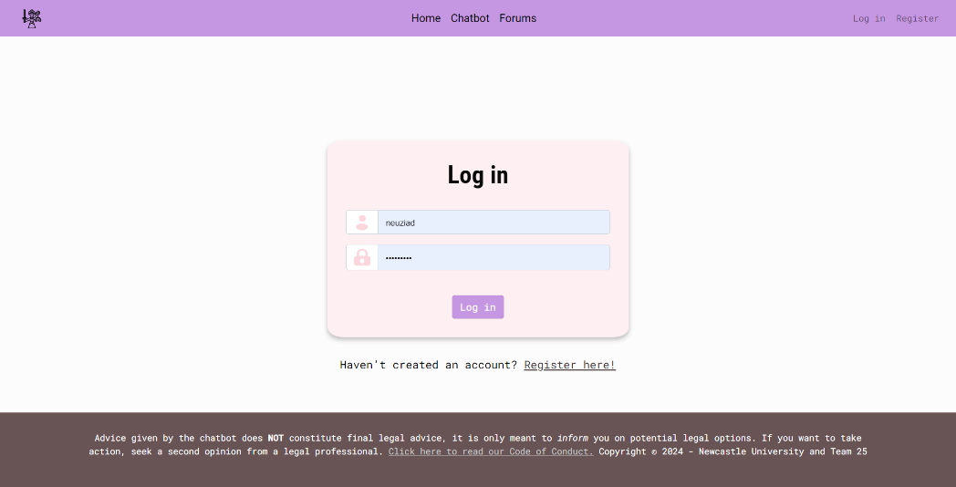User Management, Profiles & Dashboard

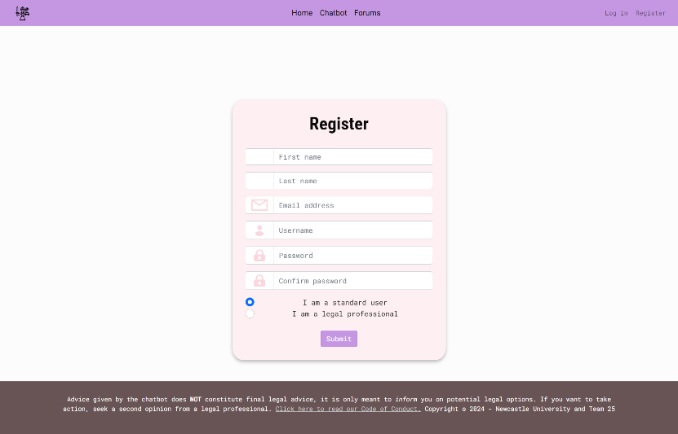Another example of Cyber Justitia’s simplicity lies within its user management interfaces. Login and register pages are standard, with uses being able to create a new account or login with their current account. The register page more specifically has a field which allows you to choose between registering as a professional (someone, ideally a seasoned professional in law, who is seeking to give advice) or user (the average citizen who is looking for help on legal matters.) When selecting the option confirming you’re a legal professional, you’ll be prompted to input a “flair,” a short sentence that will be displayed throughout your profile which summarises that specific person’s professional experience, specialties, or positions within the legal system. These flairs are prominently displayed for users to see how qualified a professional may be, especially when they’re giving certain bits of advice. All users can post and comment on the forums. Additionally, admins will have access to the admin dashboard from any user profile.

Figure 3: Log in page (with saved username and password information)

Every user has a public profile page, displaying their name, email address, description, a list of their most recent posts and comments, and for professionals, their headline flair, and credentials; all designed in a compact, single-page fashion. Depending on what kind of user they are, their profile will have a different colour palette: users with a light pink pastel colour scheme, professionals with a similar palette but with a dash of violet, and admins who have a deep purple layout. These different colour schemes allow users to differentiate between different types of users in a highly visual manner when viewing their profile. The additional text elements in the professional’s profile allows professionals to display their credentials to prove that they are knowledgeable on any given policy area or have had similar legal experience. Admins will have options to ban any user from their profile or delete any of their posts. Users will be able to delete their own posts from their profile as well.

Figure 4: Register page

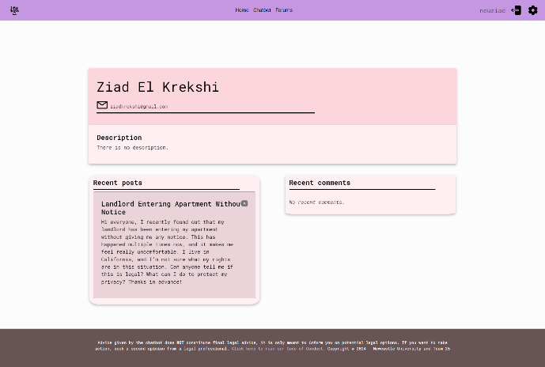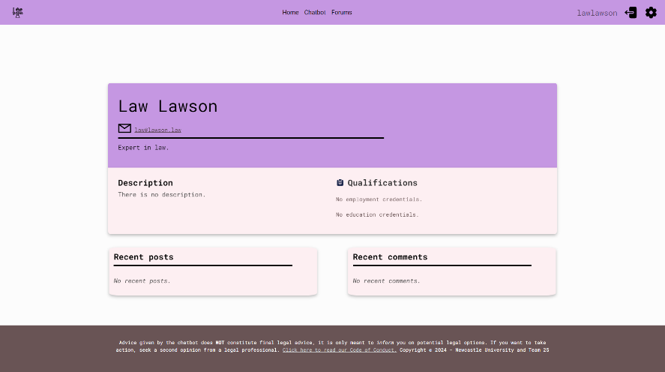

Figure 5: Example of standard user profile

Figure 6: Example of a professional user profile

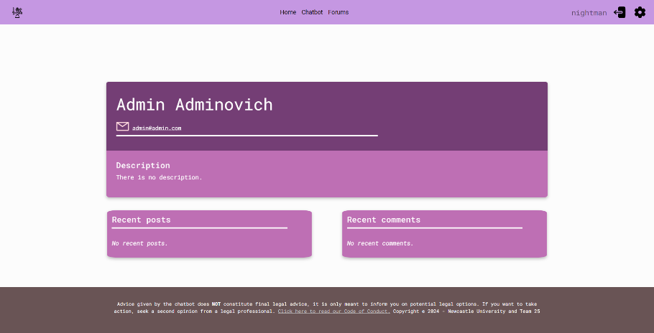

Figure 7: Example of an admin profile (from user view)

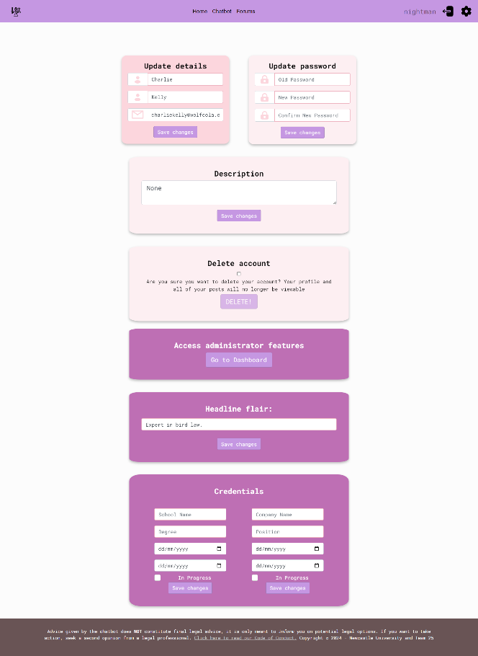All users have access to their own dashboard where users can update their details and password, as well as an option to delete their account entirely, all neatly ordered in a grid-like fashion. The modular grid design allowed for easier-to-integrate design, keeping a consistent theme with the rest of the application’s design, and simplifying the dashboard for increased accessibility. Professionals will have access to modules where they can update their credentials and their headline flair, and admins have a module directing them to Django’s built in administrator dashboard. These “blocks” are visible only to their respective user types, making it quicker to create on the front-end and while using fewer resources, by rendering all elements based on user type rather than creating individual dashboards.

Figure 8: Dashboard page (displaying all features)

Chatbot

The chatbot interface exemplifies the simplicity of Cyber Justitia. For users who are logged in, a legal disclaimer for the chatbot is shown prominently (as mentioned previously), and below that, the chatbot alongside a sessions selector, where you can save the chat sessions, and select previously saved sessions. However, sessions are exclusive to logged in users, so the only two things that appear on the page, other than the footer and navigation bar, is the disclaimer and chatbot interface. Users can input a message and ask the chatbot anything related to UK law, and Newcastle bylaws, and messages can be either sent by pressing the send button, or by hitting enter on your keyboard. This allows for a messaging experience that feels comfortable and tactile to a modern user. The user’s messages are displayed in a purple chat bubble, while the chatbot responds in a brown chat bubble; this stark colour contrast makes the chat bubbles visually discernible, even from a glance. Additionally, the chat bubbles have mostly rounded corners, except for the bottom-right-hand corner for the user message bubbles, and the bottom-left-hand corner for the chatbot message bubbles. This was an intentional design choice, to create the shape of opposing speech bubbles, in a subtle way.

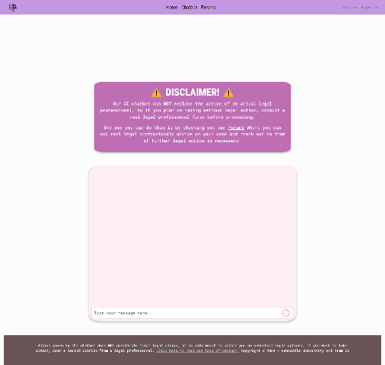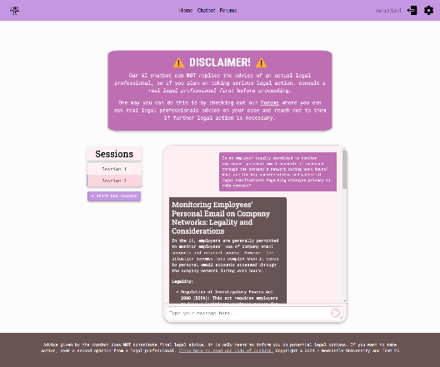

Figure 9: Chatbot page (logged out view)

Figure 10: Chatbot page (logged in view)

Forums

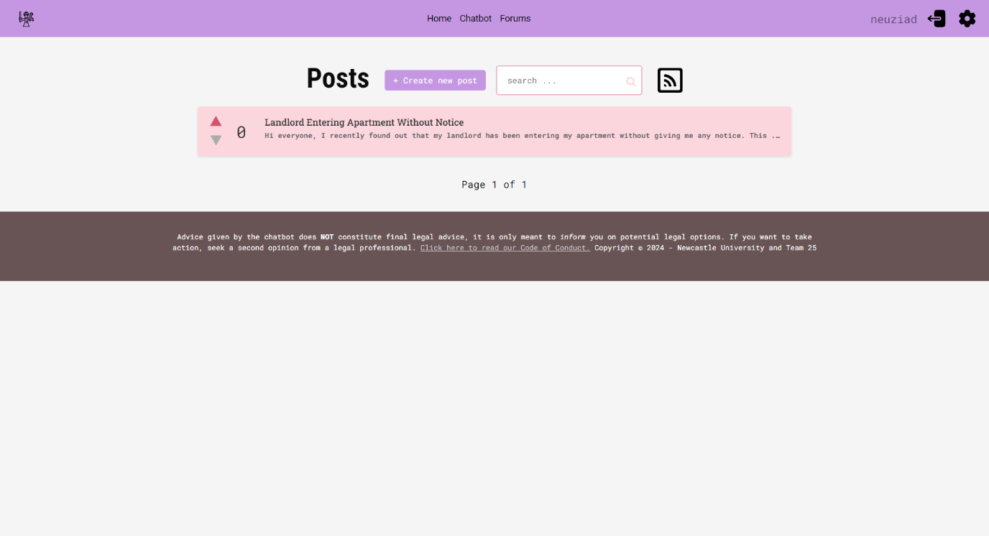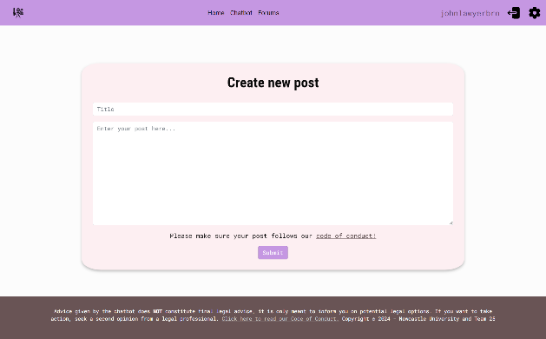The forums layout is relatively simple, but the forums pack a lot of interactive and dynamic web elements. The initial landing page displays the first 5 posts on the forums in a grid, which individually displays the post title, the first line of the post’s contents, as well as an upvote/downvote interface and the number of upvotes the post has. As a logged in user, you can upvote or downvote any post from the forum page. Above those is the main header, where a user can click on the create new post button to be redirected to a post creation page, a search bar to search by key terms, a link to the Cyber Justitia RSS feed and pagination errors where there are multiple pages worth of posts. The post creation page loads a simple form for entering a title and text body, whilst reminding the user that their post must follow our code of conduct with the simple text above the submit button. All the main features are prominently displayed at the very top, to ease navigation.

Figure 12: Forum landing page (displaying the first post)

Figure 11: Post creation page

When clicking on any given post, the user will be redirected to the post’s page, displaying the full contents of the post, as well the title, author, time, and date of post creation, upvote/downvote system and the post’s comments rendered below the main post block. Below the posts and above the comments, is a add comment button, which allows signed in users to reply to a post publicly. A small form box will appear on clicking the add comment button, allowing users to add comments quickly and easily.

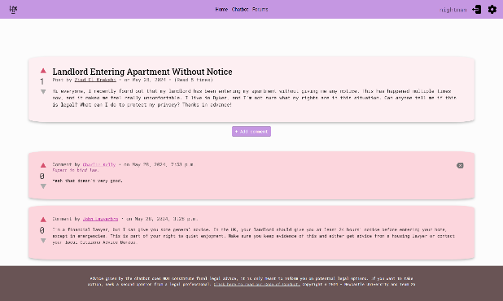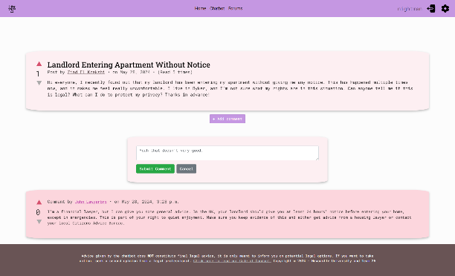

Figure 13: Forum post page (with add comment block)

Figure 14: Forum post page (displaying comment from professional)

Each comment has its own set of upvote/downvote buttons, as well as displaying the comment author, time, and date of publication, and if the user commenting is a professional, their flair in prominent magenta text (drawing visual attention to it from the start.) Authors of the post or comment will be able to delete their post/comment (and admins will be able to delete any post/comment) with a grey backspace button on the top-right-hand corner of any given post/comment. When clicked, the post/comment is immediately deleted, and the user/admin is redirected to the forum home page.

Error Landing & Miscellaneous Pages

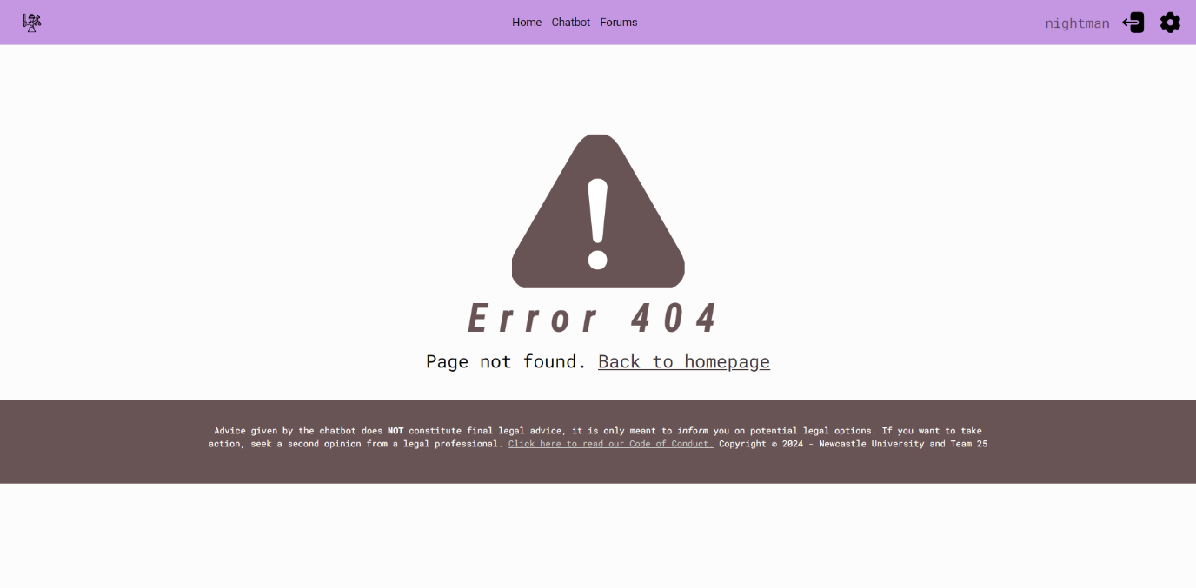Error landing pages were designed for 400, 403, 404, 500, and 503 HTTP errors, as well as landing pages for banned users (displaying the reason they were banned as well), which all follow the same visual format and simply redirect the user to the homepage with a hyperlink. Additionally, as Django’s user management system doesn’t come with banning features, a separate ban user page for admins was created. This page allows admins to confirm they want to ban a specific user, along with providing a reason for banning said user, all in a simple form box, not too dissimilar to the post creation page (instead sporting the deep violet box colour, matching the admin profile colour scheme.)

Figure 15: Example of an error landing page (404)